InvoiceManager Requirements

# Table of contents

Table of contents

Invoice production

Layout requirements

Layout selection

Layout rules

DirectDebit

Transaction summary

Transaction text on invoice

Invoice copy

Tables

Pie chart

EA Barcode

Number of pages

Attachment-handling

Invoicing process

Input

Output

Distribution to print vendor

Customer Support and MyPage

Invoice hotel

Duplicate control (not decided)

Stop duplicates

Allow duplicates

Report and reconciliation

Invoice design

General requirements

Create a new layout

Create a new layout from template

Testing

Mapping of xml-data

Mapping tables for Layout 1, Page 1

Mapping tables for Giro-part, Page 1

Mapping tables for Layout 1, Page 2

Queries

Layouts

Live Dashboard

Dashboard Details

List Brands

Manage Brands

List Grids

Manage Grids

List Templates

Manage Template

Global Configurations

Requirements on mail 20.11.17

Requirements added 22.11.17

Requirements added 28.11.17

Requirements added 07.12.17

Requirements added 14.12.17

Requirements added 15.12.17

Invoice layout for Organizations

1 - Basic template - page 1

Mapping table for basic layout, Page 1

2 - Layout with only one meter - page 1

Basic template - page 2

Mapping table for basic layout, Page 2

Heading

Strøm-table

3 - Invoices with positive amount to be paid

4 - Final Invoice version

5 - Direct Debit enabled version

6 - Metersummary

# Invoice production

## Layout requirements

### Layout selection

The Invoice Manager must support several invoice layouts. Fjordkraft must be able to generate a layout and specify which statements should get which layout.

These selections should be made based on the following information in the IF320-file:

* Brand
* LegalPartClass
* CreditLimit
* AccountCategory
* DistributionMethod

For each Brand, a set of layouts will be available based on the other elements or combination of elements listed above.

**MIN:** Does the above set contains maximum number (Brand, LegalPartClass, Account Category, DistributionMethod and CreditLimit) elements to decide Invoice template.

**ONV**: It contans all elements we have identified for now. Meaning it is a small possibility that there may be added more elements later on.

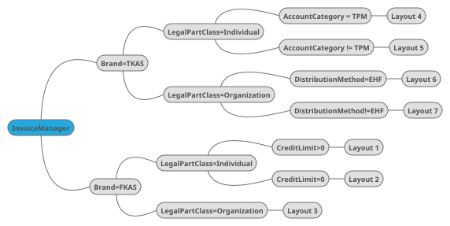

The figure above is just an illustration of the capabilities that should be possible within the Invoice Manager regarding layout selection.

Nei

If the layout manager is not able to determine a invoice layout for a statement, a error must be logged, with information about which Statement(s) that are not being produced.

Customers with the paymentsoulution called “Full kontroll” will have a specific layout. These statements are identified by the fact that the xml-element “creditlimit” is <> 0.

### Layout rules

This section lists the requirements based on the business logic that must be build into the InvoiceManager in order to achieve the requested flexibility in the layout..

#### DirectDebit

Direct debit is identified by the tag <PaymentType> and <PaymentTypeStatus>

* PaymentType = Undefined means no direct debit
* PaymentType = DirectDebit and PaymentTypeStatus=Granted means direct debit
* PaymentType = DirectDebit and PaymentTypeStatus=Cancelled means no direct debit
* PaymentType = DirectDebit and PaymentTypeStatus=InternallyGranted means direct debit
* Else, no direct debit

All invoices for utilityaccounts with direct debit granted must have the payment-table on page 1 changed to the format shown in the figure below. The two first columns are greyed out, and the text above the table are static.

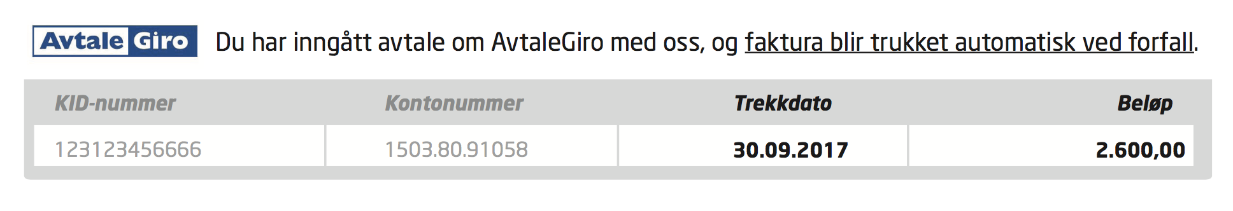

#### Transaction summary

The Invoice Manager must support the functionality of presenting a summary of certain group or types of transactions.

It must be possible to create a transaction group and define that all transactions on a statement included in this group will be presented as a sum on a certain place on the invoice layout.

Each transaction group should define a text that will be presented on the layout. The transactions can be grouped by one of the following elements from the IF320-file:

* Transaction->Distributions->Distribution->Code
* Transaction->TypeOfCharge

Each element must be able to be defined by a set of possibilities.

E.g TypeOfCharge=FINVOICE and TypeOfCharge=FNINVOICE may be defined as one group of transactions.

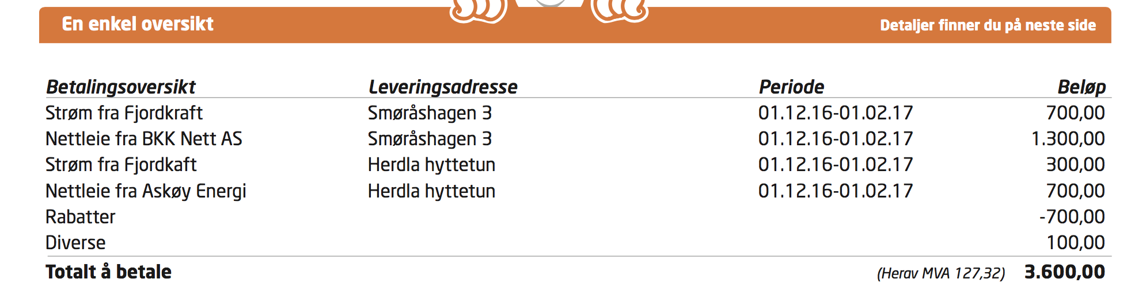

The figure above shows a table where the two rows in the end (Rabatter and Diverse) is a sum of several transactions. All other transactions are single transaction-elements directly from the IF320-file.

**MIN:** Do we have a list of transaction groups needed for phase 1. So the first release of application will support the given list of business rules which will not be configurable. Phase II of application will provide a business rules configuration engine, using which a new business rule can be introduced in the system or an existing one can be updated.

**ONV:** You can create a group called “Diverse” that consists of the following:

<TransactionCategory>DI;Forsinkelsesrente</TransactionCategory>

<TransactionCategory>DI;Papirfaktura</TransactionCategory>

#### Transaction text on invoice

Each transaction from a statement have a text that will be displayed on the invoice layout. Normally the text to display is retrieved from the element “TransactionCategory”.

E.g.: <TransactionCategory>DI;Papirfaktura</TransactionCategory>

Due to logic implemented at today's print vendor, this text is prefixed with two letters followed by a “;”. Only the text after this prefix should be printed on the layout.

Some transactions are prefixed with “FT;”. If this is the case, the text on the layout should be retrieved from the xml-element called “FreeText”. If this element contains no information, the text in “TransactionCategory” should be used as earlier described.

**MIN**: Page 1 Table 1 (En enkel oversikt) - Transaction with TransactionCategory as FT are not being used anywhere in the invoice pdf. Do we need to use these records for any calculation or can be ignored. Also Page 2 Diverse table, will also not consider these records?

#### Invoice copy

Whenever Fjordkraft distributes a copy of an invoice to a customer, the layout should clearly indicate that this is a copy.

The invoices in these cases will TBD

The Invoice Manager recognizes this by the <Version>-tag, that is 1 for the original invoice, and >1 for all later versions.

**MIN:** It is assumed that the Invoice template for all copies will remain same as the original one. If it is a copy (Version > 1), there will be an additional label somewhere in the generated PDF, indicating it is a copy.

**ONV:** Correct

#### Tables

The Invoice Manager must support creation of a table with the properties listed below.

* Header with configurable amount of columns and headings. Optional thin line below header
* Customizable lable for all rows
* Rows that may contain a transaction group as defined in this document
* Maximum number of rows before page-break.
* Reference to a specific layout template that the table is to be continued on all following pages if maximum number of rows will be exceeded on page 1.
* Footer row with an optional thin line above
* A cell in footer row may include sum of all corresponding elements from other rows besides header row
* It must be possible to ensure that information related to the same meter/address are placed on following rows. It should be possible to set which elements to sort by when defining the table
* TBD



In the figure above, the rows are based on transactions, and the transactions based on the same “leveringsadresse” are placed on following rows.

**MIN:** Most of the above changes are part of PDF template design. To address such requests, will have to update the BIRT template and re-configure / upload it to IM.

#### Pie chart

The Invoice Manager must provide Fjordkraft with the ability to put a pie chart on the invoice. The chart will show the recipient the distribution between grid and all other part of the invoice.

This means that all transaction with distributionname=NETT is included in one sum, and all other transactions in the other.

The chart must handle that a sum can become negative. In that case, the value should be set to 0.

### EA Barcode

The barcode is constructed by a maximum of 20 digits and follow this pattern:

* Position 1 is always ‘2’
* Position 2-5 is the EA-agreementnumber
* Position 6 is the servicelevel
* Position 7 is always ‘0’
* Position 8-20 is for KID or free disposal

The barcode must be of type Code128.

At Fjordkraft, positions 8-20 is populated in the following way:

* position 8-10:
  + “000” for brand FKAS
  + “111” for brand TKAS
* position 11-20: the utilityaccountnumber

Example:

For utilityaccountnumber 7032059607 from FKAS, the EABarcode looks like this: 20700100007032059607

The InvoiceManager must allow for the following configuration per brand:

* Use EABarcode for this brand, yes/no
* EA-agreementnumber
* Servicelevel
* Prefix used in KID, 3 digits

**MIN:** Queries

1. What will be the type of barcode (symbology of barcode). Looking at the pattern, it seems like **Code128**. Can you please confirm.

ONV: Confirmed Kode128



1. The 12 digit utilityaccountnumber for barcode generation corresponds to which xml tag. **ONV:** The 10 digit utilityaccountnumber is located in <AccountNumber>
2. EA-agreementnumber and servicelevel are not part of XML, will IM need to maintain this configuration. **ONV:** All 4 configurations listed above must be handled by IM

### Number of pages

Due to printing, we must make sure that the invoice always consists of an even number of pages. This means that if the layout produces an odd number of pages, we must add a blank page to the PDF between the invoice-part and the attachment-part.

### Attachment-handling

For each “strøm” end “nettleie” transaction on page one, there will be an attachment with detailed information to presented on page 2,3 etc.

For each following page, the “strøm” and “nettleie” on the same meterID from the same period should be presented on the same page.

That also implies that if an invoice consist of 3 transactions from the same meter, one strøm and two grid, the layout should be as follows:

Page 2: Strøm and grid from the same period

Page 3: The last grid (and Diverse-table if any diverse-transactions)

(The consumption table and other information on the page should be identical on page 2 and three in this case)

If none of the grid transactions match the period for the “strøm”-transaction, just pick one grid-transaction to be specified on page 2.

All attachment-details in IF320-file must be presented on the invoice, and not more than once.

# Invoicing process

Here we should describe how IM will fit in with the existing invoicing process. What are the inputs and outputs.

## Input

Input to the InvoiceManager will be a XML-file according to the UtilityAccounts IF320-file specification.

Each transaction regarding consumption and grid are in addition detailed in the attachment-tag by embedded xml-data from core systems.

The transaction and corresponding attachment is coupled by <reference> tag in transaction and <FAKTURANR> in attachment.

The attachment for consumption details are always identified by <VEDLEGG_FORMAT> = EMUXML.

<Attachment>

<FAKTURA>

<AKTOR>50153687</AKTOR>

<AKTORNAVN>&lt;![CDATA[Fjordkraft AS]]&gt;</AKTORNAVN>

<FAKTURANR>37646187</FAKTURANR>

<MAALEPUNKT>707057500040664706</MAALEPUNKT>

<FAKTURA_TYPE>FAKTURA</FAKTURA_TYPE>

<KUNDE_TYPE>P</KUNDE_TYPE>

<FAKTURA_MERKE_SO></FAKTURA_MERKE_SO>

**<VEDLEGG_FORMAT>EMUXML</VEDLEGG_FORMAT>**

<VEDLEGG_EMUXML>

<Invoice>

…

The attachment for grid details may be embedded in either EHF or e2b format in addition to the pregenerated PDF from the grid company.

In case of EHF format, <VEDLEGGFORMAT> = PDFEHF.

<?xml version="1.0" encoding="ISO-8859-1" ?>

<FAKTURA>

<AKTOR>50153785</AKTOR>

<AKTORNAVN><![CDATA[Lyse Elnett AS]]></AKTORNAVN>

<FAKTURANR>2691474-70760513</FAKTURANR>

<MAALEPUNKT>707057500069997076</MAALEPUNKT>

<FAKTURA_TYPE>UNCL1001</FAKTURA_TYPE>

<KUNDE_TYPE>P</KUNDE_TYPE>

<FAKTURA_MERKE_SO></FAKTURA_MERKE_SO>

**<VEDLEGG_FORMAT>PDFEHF</VEDLEGG_FORMAT>**

<VEDLEGG_PDF>JVBERi0xLjMKJdDS5dMK...

[Here is the pregenerated PDF]

</VEDLEGG_PDF>

**<VEDLEGG_EHF>**PD94bWwgdmVyc2lvbj0iMS4wIiBlbmNvZGluZz0iVVRG...

[Here is the Base64-encoded EHF information]

</VEDLEGG_EHF>

</FAKTURA>

In case of e2b format, <VEDLEGGFORMAT> = PDFE2B.

<FAKTURA>

<AKTOR>50153706</AKTOR>

<AKTORNAVN><![CDATA[TrønderEnergi Nett AS]]></AKTORNAVN>

<FAKTURANR>2666820-6654647</FAKTURANR>

<MAALEPUNKT>707057500067883180</MAALEPUNKT>

<FAKTURA_TYPE>Faktura</FAKTURA_TYPE>

<KUNDE_TYPE>P</KUNDE_TYPE>

<FAKTURA_MERKE_SO></FAKTURA_MERKE_SO>

**<VEDLEGG_FORMAT>PDFE2B</VEDLEGG_FORMAT>**

<VEDLEGG_PDF>JVBERi0xLjMKJdDS5dMKMSAwI...

[Here is the pregenerated PDF]

</VEDLEGG_PDF>

<VEDLEGG_E2B>PD94bWwgdmVyc2lvbj0iMS4wIiBlbmNvZGl...

[Here is the Base64-encoded e2b information]

</VEDLEGG_E2B>

</FAKTURA>

**MIN:** So if we understand correctly, there can be 3 possible values for VEDLEGG_FORMAT i.e. EMUXML, PDFEHF and PDFE2B. Some example XMLs which we have, also has a type called **PDF** which will no longer be valid now.

**ONV:** Correct

Also, can we get more details on how the values of these 3 types will be mapped to Invoice PDF.

**ONV:** They are coupled to transactions the same way <reference> - <fakturanr> as described above. The information in e2b or EHF data will be used to populate the table on page 2 (and all other pages for each meter with a corresponding grid invoice) with heading “Nettleie”.

## Output

The output from the Invoice Manager serves the following purposes:

1. Generated PDF for invoice layout will be send to printing vendor for distribution to customers along the original IF320-file.
2. All PDFs (consumption and grid) must be made available for Customer Support application and customers “MyPage” for viewing and download on request.
3. Generated PDF must be stored in Fjordkrafts Invoice-hotel.

**MIN:** Can we get more details on integration with Fjordkraft’s Invoice-hotel. We assume Straifors is doing the same today, similar protocol can be implemented in IM as well.

### Distribution to print vendor

After implementing Invoice Manager, Fjordkraft will produce the invoice layout themselves. However, the print vendor must still produce the various digital invoice formats, EHF and e2b.

As we do not want to alter the original IF320-file, the Invoice Manager must produce it’s output in such a way that both IF320 and generated PDFs can be shipped to printing vendor and make them able to couple data from IF320 with corresponding PDF from Invoice Manager.

### Customer Support and MyPage

One invoice from Fjordkraft will consist of a PDF generated from Invoice Manager, and potentially one or more pre-generated PDFs from grid companies. Each of these PDFs are uniquely coupled to an invoice number.

Fjordkraft must be able to show all this PDFs in their internal web-applications, in such a way that they choose an invoice number, and all corresponding PDFs may be viewed within the application or downloaded by the user.

**MIN:** This means that the Invoice XML, final Invoice PDFs and PDFs part of Invoice XML should be accessible and downloadable from IM (service or My Page).

### Invoice hotel

This issue is not directly related to the Invoice Manager, and for the time being Fjordkraft is using an external Invoice hotel located at their print vendor. In future, Fjordkraft may want to implement their own Invoice hotel meaning that the PDF generated by Invoice Manager must be stored locally and be available to the Invoice hotel application.

**MIN:** This activity can be planned in the next phase of IM development. IM anyways will hold all Invoice PDF, transferring them to a hotel or building a hotel of its own should not be a big activity.

## Duplicate control (not decided)

### Stop duplicates

The Invoice Manager must as default behaviour support duplicate control based on invoice number. The invoice number is generated by the concatenation of “accountnumber” and “sequencenumber” from the Statement-tag.

If a duplicate is registered, Invoice Manager must log a warning and stop production of the duplicate PDF(s). All other PDF production must proceed as normal.

### Allow duplicates

The Invoice Manager must support allowing for duplicate PDF generation. This should be accomplished by telling the Invoice Manager that a set of certain invoice numbers should allow duplicate invoice production.

**MIN:** Once the requirements are complete, a duplicate invoice generation controlled can be built in IM which will allow generation of specific duplicate statements and blocking rest all duplicates. This again can be planned in the next phase of IM development.

## Report and reconciliation

The Invoice Manager should allow for the following information to be enquired:

* Status of a specific IF320-file
  + Number of statements generated ok from file
  + Number of statements from file not generated (with reason for not generating)
  + Status on file (not produced, in progress, finished)
* Status on a specific Statement (invoice number)
  + Step in generation process
  + Name on file where PDF is located
* Status on a specific date
  + List all IF320-files handled this day

**MIN:** IM will have a dashboard with real time updates of what’s happening within the system. Search capabilities will allows to find specific invoice information. Designs will be shared before we start with the dev activities of Dashboard.

**ONV:** APIs for retrieving this is probably the most important thing. I guess we would like to integrate this information in existing applications

# Invoice design

## General requirements

* Any component from <Statement>-tag must be available for the layout designer to put on the layout-design
* Information from EHF or e2b details in attachment connected to a transaction, must be available to the transaction-element from <Statement>.

## Create a new layout

## Create a new layout from template

## Testing

The Invoice Manager must be able to run layout generation in test-mode. This means that Fjordkraft may upload a IF320-file to Invoice Manager to verify that all statements are handled in correct manner, and layouts looks correct without generation of export files.

# 

# 

# Mapping of xml-data

Here we will document how to map the various information on the layout to xml-elements

Layout 1, page 1

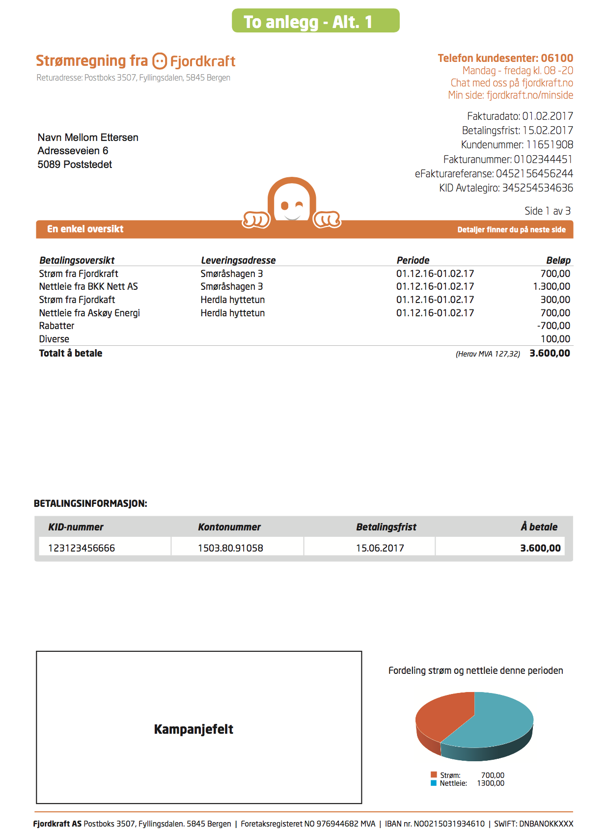

## Mapping tables for Layout 1, Page 1

**Address**

|  |  |  |
| --- | --- | --- |
| **Layout element** | **Tag** | **Comment** |
| Navn Mellom Ettersen | CareOfName | Name if careofname is empty |
| Adresseveien 6 | Address1  Address2 |  |
| 5089 | PostCode |  |
| PostStedet | City | If Region<>NO, then Country also must be written under PostCode |

**Invoice details**

|  |  |  |
| --- | --- | --- |
| **Layout element** | **Tag** | **Comment** |
| Fakturadato | StatementDate |  |
| Betalingsfrist | DueDate |  |
| Kundenummer | NationalId |  |
| Fakturanummer | AccountNumber+SequenceNumber |  |
| eFakturareferanse | AccountNumber |  |
| KID Avtalegiro | StatementOcrNumber |  |

**Transaction table**

|  |  |  |
| --- | --- | --- |
| **Layout element** | **Tag** | **Comment** |
| Betalingsoversikt | TransactionCategory | If the corresponding element in emuxml-attachment has invoicetype=O, then the word “OPPHØR” should be appended. |
| Leveringsadresse | FreeText | For transactioncategories that starts with “NE;” and “KR;” |
| Periode | <StartDate> - <EndDate> | For KRAFT:From attachment  **min:** Does this corresponds to <StartDate> - <EndDate> from <ReadingInfo-111> tags or <StartDate> is the startdate of first <InvoiceLine-120> and <EndDate> corresponds to the end date of last <InvoiceLine-120> tag ?  ONV: ReadingInfo-111 should be used  For “Nettleie”, the first startdate and last todate from invoicelines in EHF/E2B must be used. |
| Beløp | AmountWithVat |  |
| Herav MVA | TotalVatAmount |  |
| Totalt å betale | CurrentClaim | **MIN**: What is the message that needs to be displayed if the value is negative ? |

**Min:** If rows in the Transaction Table spills over to next page. On first page, instead of total, we need to display some text such as “Continued to next page” etc. Please provide the text in Norwegian

ONV: “Forts. neste side.”

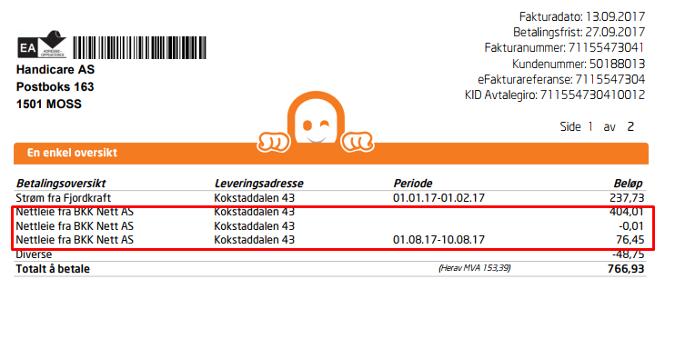

**Paymentinfo table**

|  |  |  |
| --- | --- | --- |
| **Layout element** | **Tag** | **Comment** |
| KID nummer | StatementOcrNumber |  |
| Kontonummer | N/A | Configuration parameter |
| Betalingsfrist | DueDate |  |
| Å betale | CurrentClaim |  |

Layout 1, page 2

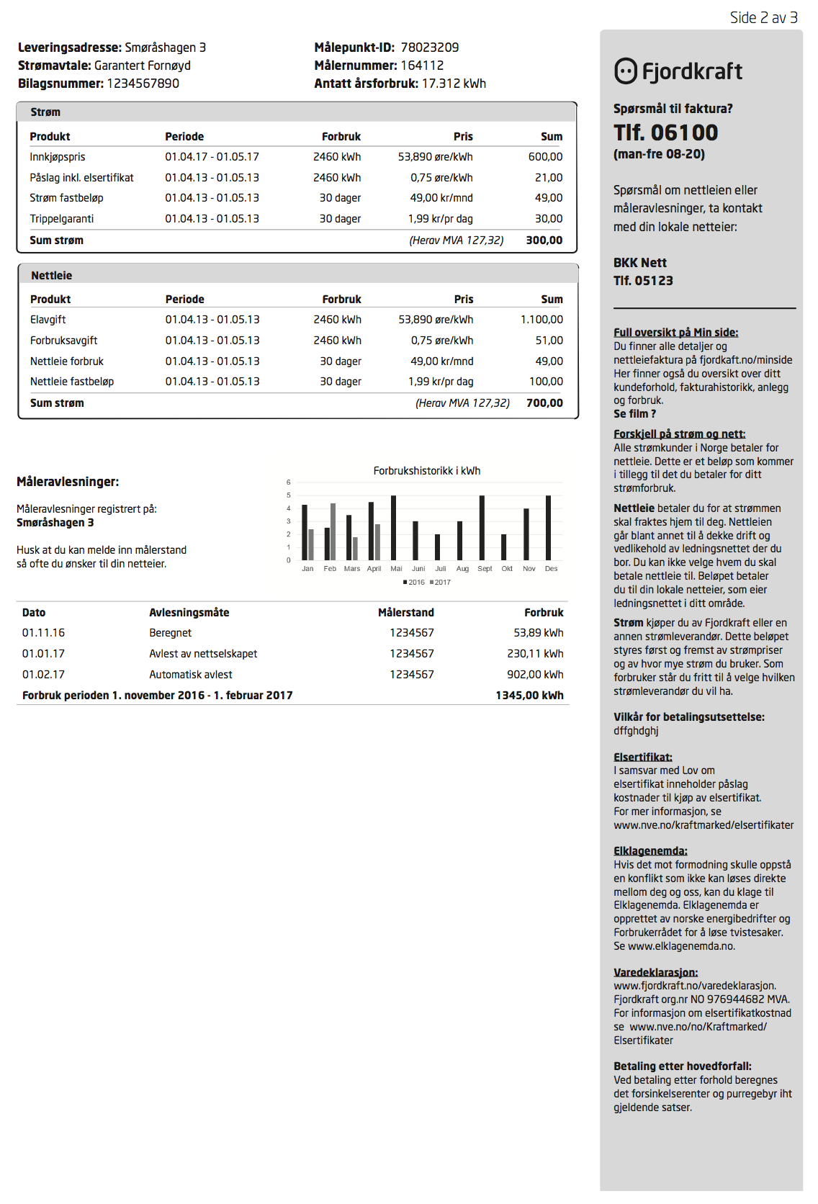

## Mapping tables for Giro-part, Page 1

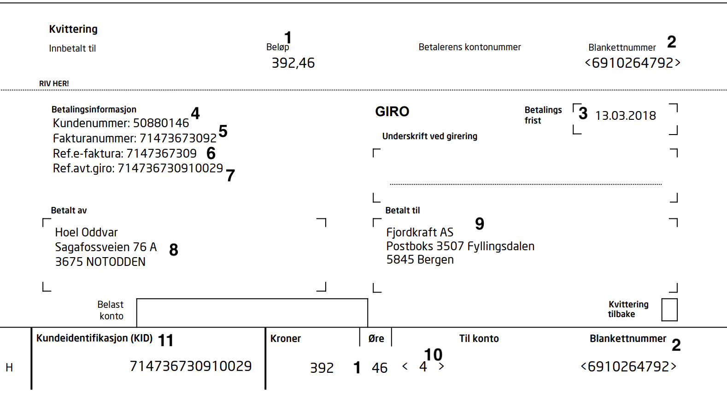

|  |  |  |
| --- | --- | --- |
| **Layout element** | **Tag** | **Comment** |
| 1 | <CurrentClaim> |  |
| 2 | Internal IM-logic with range of numbers provided by Fjorddraft |  |
| 3 | <DueDate> |  |
| 4 | <NationalID> |  |
| 5 | <accountnumber><sequencenumber> | Concatenated |
| 6 | <accountnumber> |  |
| 7 | <statementocrnumber> |  |
| 8 | Same as Address |  |
| 9 | Brand configuration in IM |  |
| 10 | Checksum calculated of <currentclaim> |  |
| 11 | <statementocrnumber> |  |

## Mapping tables for Layout 1, Page 2

**Meter details**

|  |  |  |
| --- | --- | --- |
| **Layout element** | **Tag** | **Comment** |
| Leveringsadresse | supplypointinfo-117-> streetno | If streetno is not present, use Freetext from transaction |
| Strømavtale | Description | From attachment within ProductParameters-118 |
| MålepunktID | ObjectId | From attachment |
| Målernummer | MeterId | From attachment |
| Antatt årsforbruk | AnnualConsumption | From attachment |
| Bilagsnummer | InvoiceNo | From attachment, but will probably not be used in the final version |

**“Strøm” table**

All information is from the attachment with <VEDLEGG_FORMAT>=EMUXML.

Each line in the table corresponds to a InvoiceLine-120.

Min: Any filtering on the InvoiceLine-120 rows?. While preparing the first mapping we found few of the InvoiceLine-120 rows were filtered. Will check

ONV: Not that I know of at the moment. Can you give me an example?

|  |  |  |
| --- | --- | --- |
| **Layout element** | **Tag** | **Comment** |
| Heading (“Strøm”) | If invoicetype=O  then this is a final invoice, and heading should be “OPPHØR strøm”  <InvoiceType>O</InvoiceType> | **Normal heading:** “Strøm”  **Final invoice heading:** “OPPHØR strøm” |
| Referansenummer | <InvoiceNo> | Heading |
| Product | Text |  |
| Periode | StartDate - EndDate |  |
| Forbruk | Basis  **For Individuals:**  If value in Basis ==1, then use value in <NoOfDays> with Denomination=”Dager”  E.g.  <Basis>1.000</Basis><NoOfDays>12</NoOfDays> | Note: Denomination |
| Pris | GrossPrice  If pricedenominaction == øre/kWh, the value in GrossPrice must be multiplied with 100  E.g.  If <Gross>0.04490</Gross> and <PriceDenomination>&lt;![CDATA[øre/kWh]]&gt;</PriceDenomination> the price should be displayed as “4,49 øre/kWh” | Note: Denomination |
| Sum | TotalGross |  |
| Herav MVA | VAT |  |
| Sum strøm | GrossTotal |  |

**Min:** Didn’t get you when you say table corresponds to transaction. Strom table rows corresponds to <InvoiceLine-120> tags right?

ONV: I meant that the information in cell with label Leveringsadresse can be retrieved from the element FreeText in Transaction. I think it also is contained somewhere within InvoiceLine-120 as well, but then it might contain some additional text.

**Exceptions**

Note that invoice lines from emuxml that include “Fornybar energi” should not be included in the table. The figure below shows two such lines that should be deleted from the table.

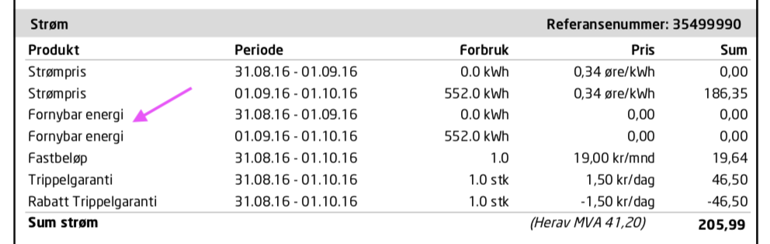

**“Grid” table - EHF-format**

|  |  |  |
| --- | --- | --- |
| **Layout element** | **Tag** | **Comment** |
| Referansenummer | <cbc:ID> | Heading |
| Product | <cbc:Name>Nettleie</cbc:Name> |  |
| Periode | cac:invoiceperiod, cbc:startdate, cbc:enddate. |  |
| Forbruk | <cbc:InvoicedQuantity unitCode="KWH" unitCodeListID="UNECERec20">17500.000</cbc:InvoicedQuantity> | unitCode contains denomination  If unitCode="DAY", then “dager” should be printed |
| Pris | <cac:Price><cbc:PriceAmount currencyID="NOK">16.6000</cbc:PriceAmount><cbc:BaseQuantity>100</cbc:BaseQuantity></cac:Price> | BaseQuantity=100 means that the price is 0,166 in this example  Only 3 decimals |
| Sum | <cbc:LineExtensionAmount currencyID="NOK">2800.00</cbc:LineExtensionAmount> + cbc:TaxAmount |  |
| Sum Nettleie (final row) | <cbc:TaxInclusiveAmount currencyID="NOK"> |  |
| Herav MVA (final row) | <cbc:TaxAmount currencyID="NOK"> |  |

**“Grid” table - E2B -format**

|  |  |  |
| --- | --- | --- |
| **Layout element** | **Tag** | **Comment** |
| Referansenummer | <InvoiceNumber> | Heading |
| Product | <Description> |  |
| Periode | <StartDate> - <EndDate> |  |
| Forbruk | <QuantityInvoiced> | Denomination: <UnitOfMeasure> |
| Pris | <Ref> <Code>UnitPriceGross</Code>  <Text>0.17500</Text>  </Ref> | Denomination: <PriceDenomination> |
| Sum | <LineItemGrossAmount> |  |
| Sum Nettleie (final row) | <GrossAmount> |  |
| Herav MVA (final row) | <VatTotalsAmount> |  |

**Consumption-table**

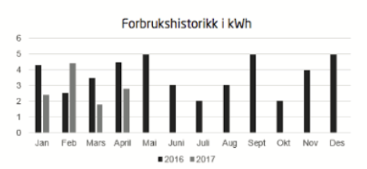

Information in this table should be retrieved from the emuxml file in xml-tag <ConsumptionPillars-132>

Note that the bars should be displayed from left to right in the reversed order from which they are listed in the file. Meaning the LastYearConsumption12 and ThisYearConsumption12 should be placed to the left, then 11, 10 and finally LastYearConsumption1 and ThisYearConsumption1 to the right.

Layout 1, last page

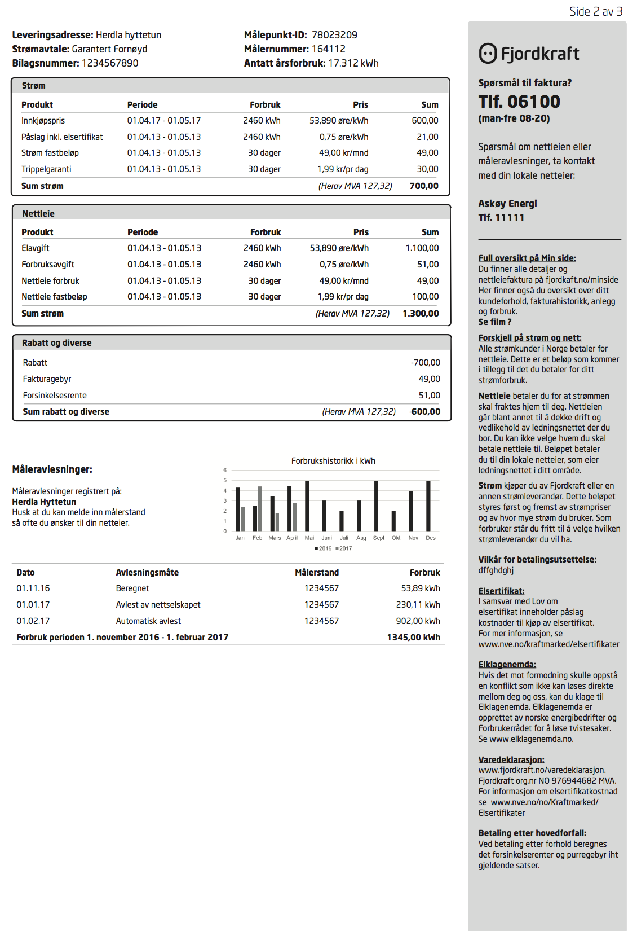

# Queries

* Verify that the barcode generated using IM is correct.
  + Yes
* How to represent the positive and negative values in Page 1 Table 1 (En enkel oversikt).
  + Fjordkraft will get back on this.
* How to fetch information for Page 2 -> Table 2 (Nettleie ), 3 (Rabatt og diverse) & 4 (below bar graph)
  + Fjordkraft will get back on this.
* Filtering of information on Page 2 -> Table 1 (Strøm)
  + Fjordkraft will get back on this.
* Denomination of Antatt årsforbruk on Page 2 header will always be kWh.
  + Yes
* If the Pris value is empty (in XML) or 0 for Page 2 -> Table 1 (Strøm), what should be displayed in PDF for that. Should we keep it as 0,00 or left it empty. Also, if the denomination is not part of XML data for some nodes, what should be the default denomination to be used. Please note that, looking at the XML data, it is observed some of the values may have denomination whereas other may not have.
  + Fjordkraft will get back on this.
* Canvas size of Ads PDF is different, do IM need to do some formatting.
  + No formatting is needed at IM. IM will always received the correct copy which will be attached as is.
* Size of the campaign image and Ads PDF is large. If we attach them as-is, size of final invoice PDF increases. Do IM needs to do any compression.
  + No compression is needed at IM. IM will always received the compressed copy which will be attached as is.
* How will the delivery of ready PDFs will be done to Stralfors.
  + AFI will pick all ready records from IM in batches. IM need not to push ready PDFs to AFI or Stralfors.
* Please provide the templates for different brands. What we have today is the single template.
  + Fjordkraft will get back on this.
* Regarding Full kontroll - ett anlegg, how should the Customer balance (kr. 259,-) (highlighted below) needs to be calculated.
* Need statistics on max number of invoice that will be generated for a given day.
* Statistics on maximum number of batches to be processed for a day.
* What will be the archiving strategy for generated invoice pdfs. How much long the generated invoice pdfs should be retained in the database.
* What is difference between E2B and EHF format ? In which scenario EHF format be generated and in which scenarios E2B format will be generated.
* Need mapping of 2 and 3rd table based on the sample files provided for EHF/E2B format.
  + 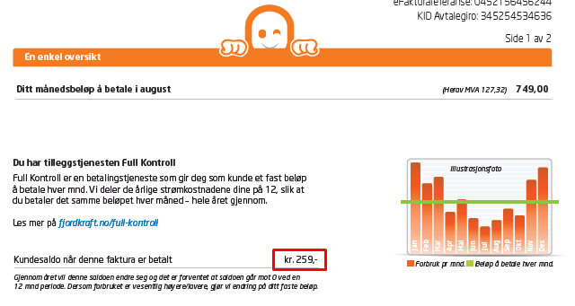
  + 1) For kr amount 259,65 - it should display as 259,65-

2) For kr amount 259 - it should display as 259,-

* + Detail below En enkal oversikt should have month name which should match with month number in statement date.
  + On the template without the pie-chart, the image will have dimension width=18,5cm and height= 3,5 cm

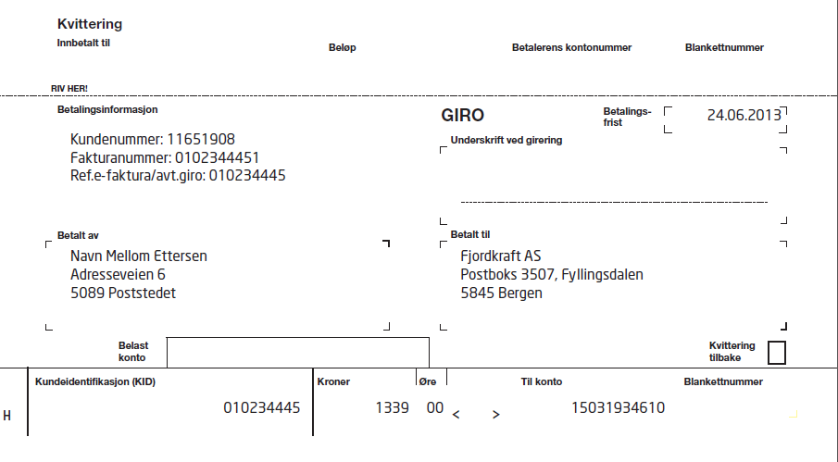

**Queries related to template Faktura_med giro-1:**

* From which tag or table we can find the data to display under ‘Betalt til’ ? (ONV: Configuration per brand)
* What are all the data are static here in the above screenshot ?
* What is 1339, 00 (ONV: That is the amount to pay, currentclaim) and 15031934610 (ONV:bankacountnumber, configuration per brand)? From where we can find the data ?
* What is the size of the section ?
* First attachment data page (Page 2) has pie chart at end, second (page 3) has Diverse table, Attachment depends on Strom/Kraft transaction. There might be more than 2 attachments in the statements. What is the design if there are more then 3 page ?
  + Pie chart needs to be calculated based on meter.
* What are the layout selection rules for this template ?

# 

**Queries related to template Faktura_med giro-3:**

* Please give us the mapping for the data present in this section.
  + 3.600,00 here is Current claim.
  + 02.03.2017 is Due date.
  + BIC and IBAN is configurable in database.
* What is the size of the section ?
* Attachment data page (Page 2) has campaign image at end. Attachment pages depends on number of transactions. What needs to be displayed in further pages ?
* What are the layout selection rules for this template ?

Queries related to FKAS example statement file shared in email:

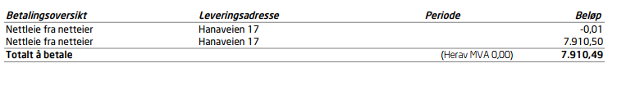

* There is no Strom/Kraft transactions. So, second page will have no data in this case. Please confirm whether the case like this exists. If exists, how an invoice PDF should be ?
  + ONV: Yes, this can happen. In this case, no changes to the other part of the layout. Meaning first page and attachment as normal.

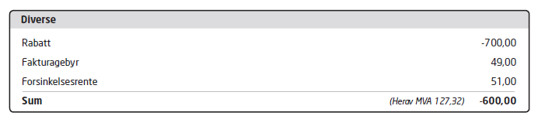

Queries related to Diverse table:

* In which page we need to show this table (Page 2 or Last page or all the pages) ?
  + Diverse table only on last page.

Queries on Feedback.

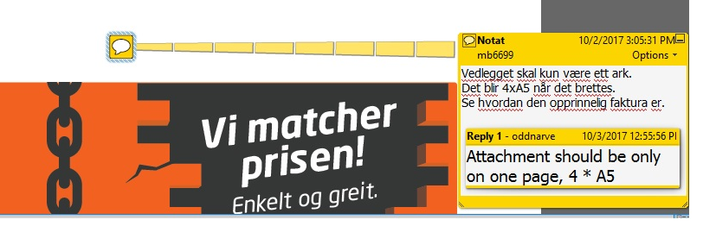

Need more details on the feedback in the pic above. What exactly is required ?

# Layouts

## Live Dashboard

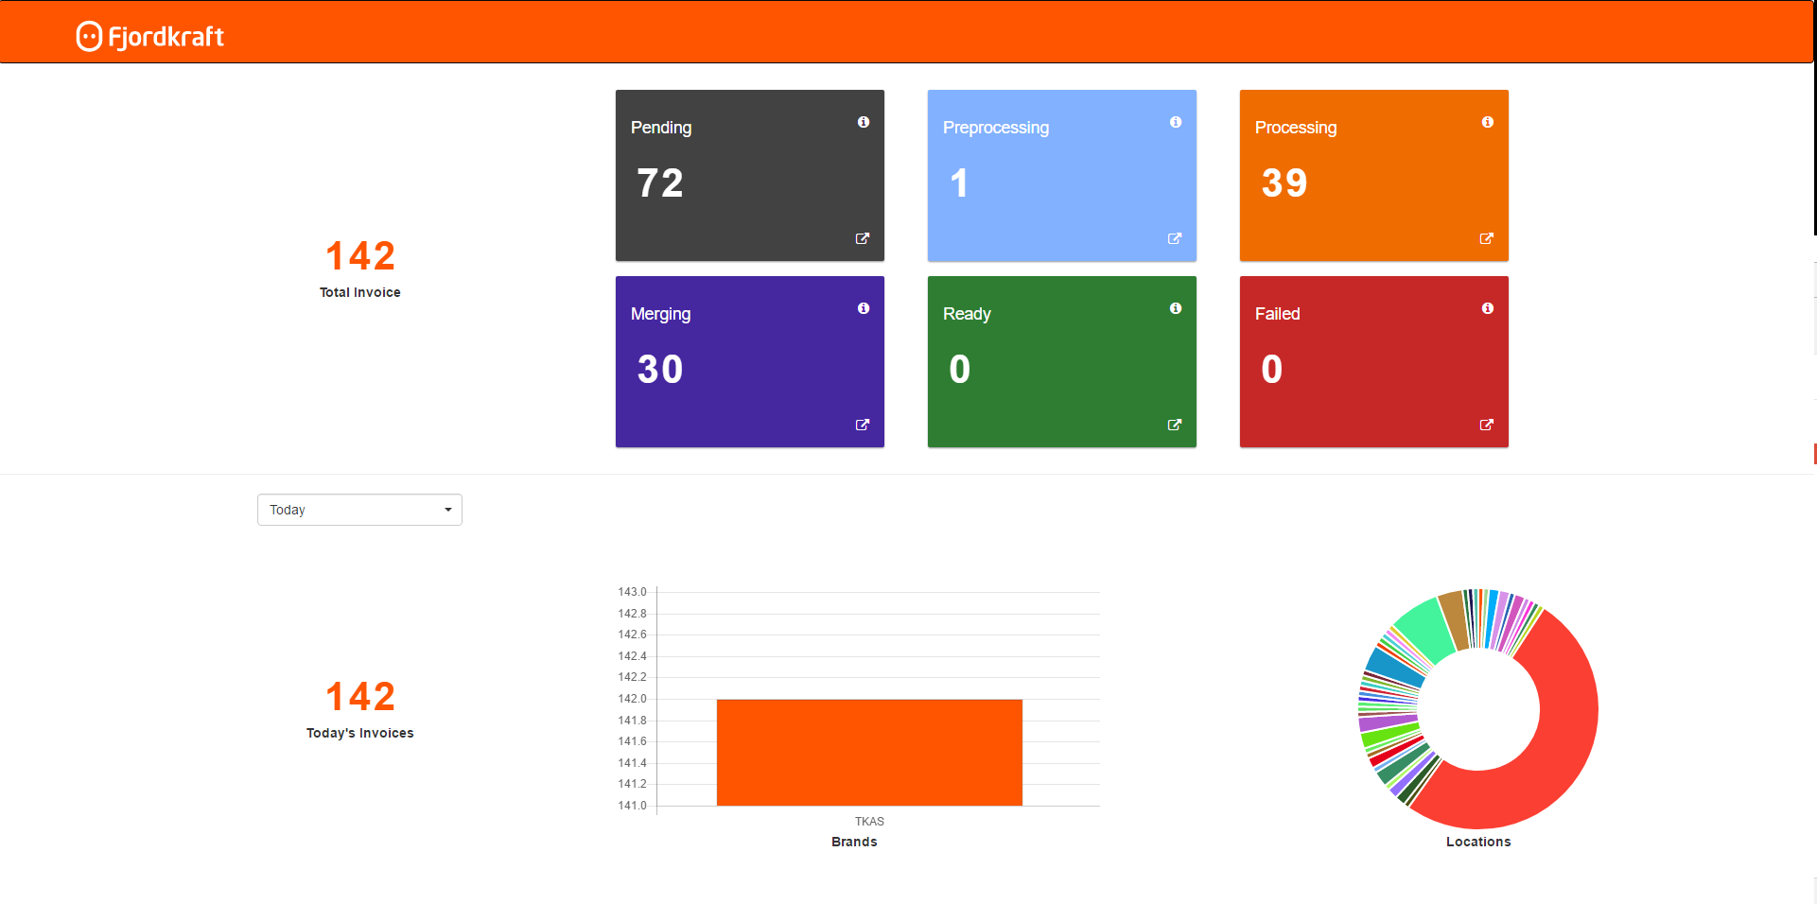

## Dashboard Details

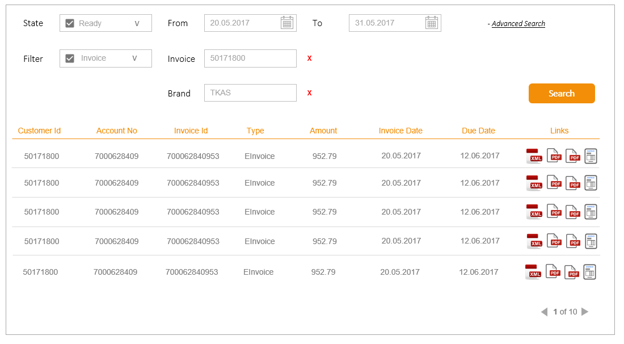

## List Brands

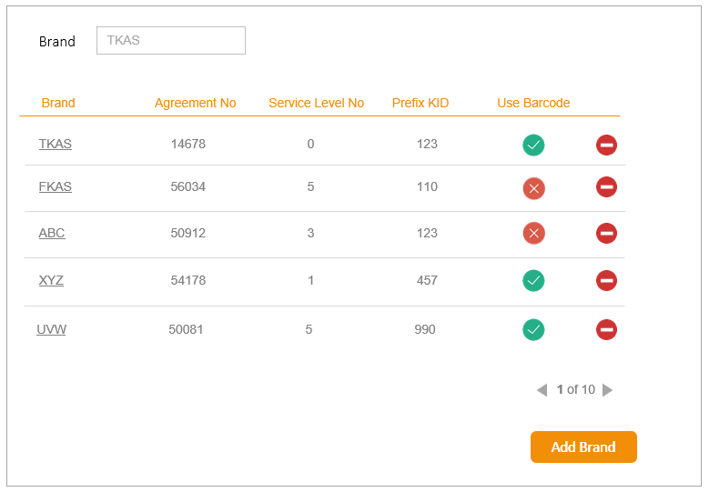

## Manage Brands

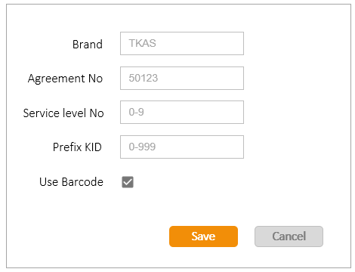

## List Grids

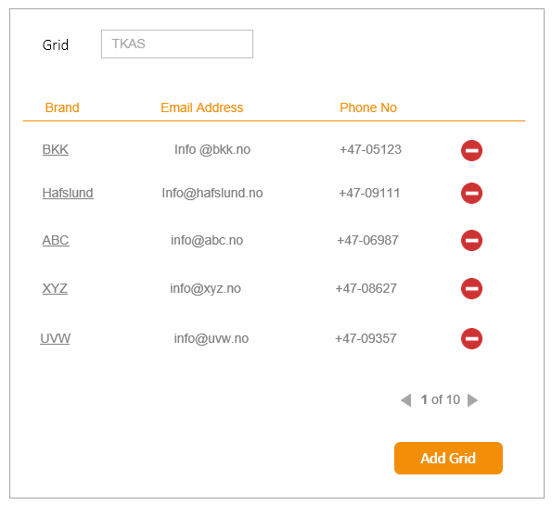

## Manage Grids

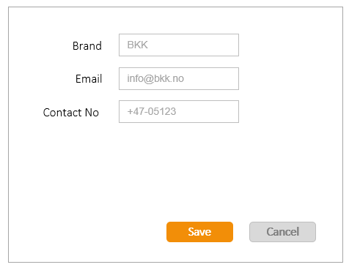

## List Templates

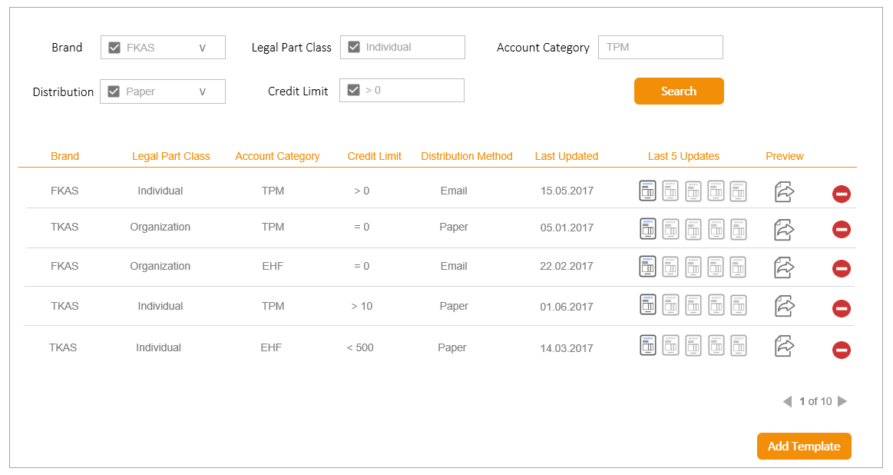

## Manage Template

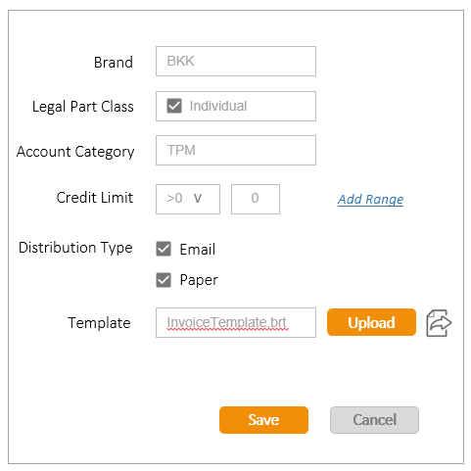

## Global Configurations

*TBD*

## Requirements on mail 20.11.17

**Comment 1:**

The grid-invoices should be printed in the following order:

On page 1:

Grid and utility from the same period always together, the list should be ordered by period, newest on top.

The following pages should follow the same order as the table on page 1.

**Comment 2:**

The prices in grid invoicelines (UnitPriceGross) seems to be in “kroner (1 krone = 100 øre) even though the denomination is “øre/kWh”.

The example below should therefore be printed as “14 øre/kWH” and not “0,14 øre/kWh”. (Don´t ask me why this is so…)

<BaseItemDetails>

<Description>Nettleie energi </Description>

<UnitPrice>0.11200</UnitPrice>

<PriceDenomination>øre/kWh</PriceDenomination>

<LineItemAmount>-13.66</LineItemAmount>

<LineItemGrossAmount>-17.08</LineItemGrossAmount>

<QuantityInvoiced>-122.000</QuantityInvoiced>

<UnitOfMeasure>kWh</UnitOfMeasure>

<VatInfo>

<VatPercent>25.00</VatPercent>

<VatBaseAmount>-13.66</VatBaseAmount>

<VatAmount>-3.42</VatAmount>

</VatInfo>

<Discount>

<Percent>0.00</Percent>

<Amount>13.66000</Amount>

</Discount>

<StartDate>2017-08-01</StartDate>

<EndDate>2017-09-01</EndDate>

<Ref>

<Code>Type</Code>

<Text>AVL</Text>

</Ref>

<Ref>

<Code>UnitPriceGross</Code>

<Text>0.14000</Text>

</Ref>

</BaseItemDetails>

## Requirements added 22.11.17

**Requirement 1 (Pri 1):**

In “Strøm-table” on page 2:

Invoice lines with price=0 AND sum <> 0, the price should not be printed in table, leaving that cell blank.

(If both price and sum equals 0, price should be printed)

**Requirement 2 (Pri 2):**

On page 2, in grid table, there are rows like this:

Example 1:

Nettleie fastbeløp 18.09.17 - 01.10.17 1.0 243,750 kr/mnd 105,63

Example 2:

Fastbeløp 01.10.17 - 01.11.17 0.08492852 år 1.434,000 121,79

Where nr. 1 is about a monthly charge, and the second a yearly charge. The third column in these cases should list the number of days calculated by 2. column, e.g. “13 dager” instead of “1.0” or “0.08492852 år”.

The startdate is included, the todate is excluded. 18.09.17 - 01.10.17 is 13 dager

For attachments of type EHF, this can be identified by xml-tag <cbc:InvoicedQuantity unitCodeListID="UNECERec20" unitCode="ANN">0.10137</cbc:InvoicedQuantity> where unitCode = ANN og MON

For attachments of type e2b, this can be verified by the xml-tag <PriceDenomination>kr/mnd</PriceDenomination>, in cases where this equals “kr/mnd” or “kr/år”

**Requirement 3 (in production):**

For EHF-files, the price on each invoiceline is listed without VAT. VAT must be added on the price in the table according to the VAT-percentage listed on each invoiceline

**Requirement 4 (Pri 3):**

On page 2

* In all tables, price should only have 2 decimals
* Column “Forbruk” all tables, no decimals here
* Column “Forbruk” “strøm-table”, small letter “d” in “dager” (not “Dager”).
* In grid table, write “nok” not “NOK, and “kWh” not “kwh”

## Requirements added 28.11.17

**Requirement 1: Attachment should be A4**

We did a change a while ago where attachments should be displayed as 4 pages in A5 format. Fjordkraft has now determined that they do not want that. They will instead provide us with an attachment that should be just added without any changes from our side.

**Requirement 2: Merge invoicelines in gridtable**

Some gridowners send invoicelines that should be merged into one invoiceline on our grid-table. We must be able to configure for each gridowner a set of invoicelines that should be merged. E.g “enova avgift” and “forbruksavgift” should become “Nettleie forbruk”. Price and sum values on these lines must then be added in the merged line.

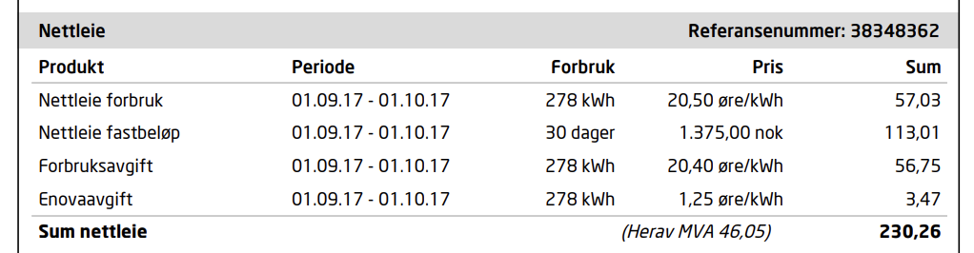

The result after merging “Forbruksavgift” and “enoveavgift” from the table above should then be:

“Nettleie forbruk 01.09.17 - 01.10.17 278 kWh 21,65 øre/kWh 60,22”

The period, consumption and all denominations will always be identical for these invoice lines that are merged.

**Requirement 3: Check if sum on page 1 validates against page 2 (and later pages)**

The sum of all transactions in table on page 1 should match the sum of all tables on later pages.

(Due to some missing grid-details on earlier transactions, this validation will only be valid for grid-transactions with corresponding xml-details provided in IF320)

We want the processing of invoices that do not validate according to this (except those with missing details) to be stopped, and we are informed about the validation error. No invoice should be generated without this validation ok.

## Requirements added 07.12.17

**Even number of pages before attachment (already implemented)**

The amount of pages on the PDF before adding attachment must always be an even number. If not, a blank page must be added before the attachment.

**Total amount of pages must always be an even number**

If the PDF after adding the attachment consist of an odd number of pages, a blank page must be added to the end of the document resulting in an even number of pages.

## Requirements added 14.12.17

**One transaction consisting of several specifications in emuxml**

Fjordkrafts intention is to always has a one to one relation between a row in the table on the first page with one table on the following page.

So if the invoice e.g. consists of consumption and grid for 2 meters, the first page should list all 4 transactions like this

Strøm meter1

Grid meter1

Strøm meter2

Grid meter 2

However, for some customers, both meters are included in 1 transaction from IF320 and hence also in one <Invoice> in the emuxml-file.

For these cases we need to split the information in order to present it correct on the invoice.

All these transactions will have multiple Distribution-elements of type “Kraft” representing each meter.

<Transaction>

<TransactionId>85703442</TransactionId>

<ParentTransactionId/>

<TransactionType>Charge</TransactionType>

<TransactionCategory>KR;Strøm fra Fjordkraft</TransactionCategory>

<TransactionDate>2017-12-09</TransactionDate>

<ValueDate>2017-12-27</ValueDate>

<Amount>-1646.99</Amount>

<VatAmount>-411.74</VatAmount>

<AmountWithVat>-2058.73</AmountWithVat>

<Reference>41548133</Reference>

<Url/>

<FreeText>Veksthusfløtten 50</FreeText>

**<Distributions>**

**<Distribution>**

**<Name>Kraft</Name>**

**<Amount>-1909.75</Amount>**

**</Distribution>**

**<Distribution>**

**<Name>Kraft</Name>**

**<Amount>-148.98</Amount>**

**</Distribution>**

**</Distributions>**

<CollectionFeeForStatements/>

</Transaction>

So the transaction above, should be listed in the table on page one as follwows:

|  |  |  |  |
| --- | --- | --- | --- |
| Betalingsoversikt | Leveringsadresse | Periode | Beløp |
| Strøm fra Fjordkraft | Veksthusfløtten 50 | 01.11.2017-01.12.2017 | 1909,75 |
| Strøm fra Fjordkraft | Lørenvangen 42 | 03.11.2017-01.12.2017 | 148,98 |

Mapping:

* For betalingsoversikt, both rows use the information from the same transactioncategory
* For leveringsadresse the address is collected from the emuxml, element SupplyPointInfo-117 -> StreetNo

As the Invoice-element in emuxml consists of 2 <InvoiceOrder>-elememts, the correct element must be identified by matching the amount in the distribution. In the example above, one invoiceorder has amount 148,98, and the other has amount 1909,75

* For periode the startdate-enddate from corresponding invoiceorder is used (as before)
* For beløp the amount in Distribution is used.

## Requirements added 15.12.17

**Mapping of data on page 2 for only grid table**

**EHF:**

|  |  |
| --- | --- |
| Leveringsadresse | Delivery: <cbc:StreetName>Jacob Aalls gate 57</cbc:StreetName> |
| Strømavtale | N/A (Do not show) |
| MålepunktID: | <cbc:ID schemeAgencyID="9" schemeID="GSRN">707057500051813865</cbc:ID> |
| Målernummer: | <cac:AdditionalDocumentReference>  <cbc:ID schemeAgencyName="Hafslund" schemeName="Malernummer">7359992897019444</cbc:ID>  If no målernummer is found as shown above, use this:  <cbc:Note>Målernummer: **38106698**. Leveringspunkt: 115711 008 1 Nedre Møllenberg gate 79 Etg.:1 7043 TRONDHEIM </cbc:Note>  We also want a log for all invoices where målernummer is not found. |
| Forventet årsforbruk | N/A (Do not show) |

**E2B:**

|  |  |
| --- | --- |
| Leveringsadresse | <MeterLocation>Bjuneveien 490 Etg.:1 Leil.:H0101</MeterLocation> |
| Strømavtale | N/A (Do not show) |
| MålepunktID: | EnergyHeader: <ObjectId>707057500040738872</ObjectId> |
| Målernummer: | EnergyHeader: <MeterId>TE053614414</MeterId> |
| Forventet årsforbruk | N/A (Do not show) |

# 

# Invoice layout for Organizations

Organizations will have a different invoice layout then individuals. There will be 5 different variations of this layout, all based on the same template. These are:

1. Invoice with several meters (Basic layout)
2. Invoice with only one meter
3. Invoice with positive amount to be paid
4. Final invoice (will be valid in combination with both other types)
5. Invoices with enabled directdebit

Note that for organizations, there will always be only one Distribution per transaction. If not, the invoice should be sent to failed state.

## 1 - Basic template - page 1

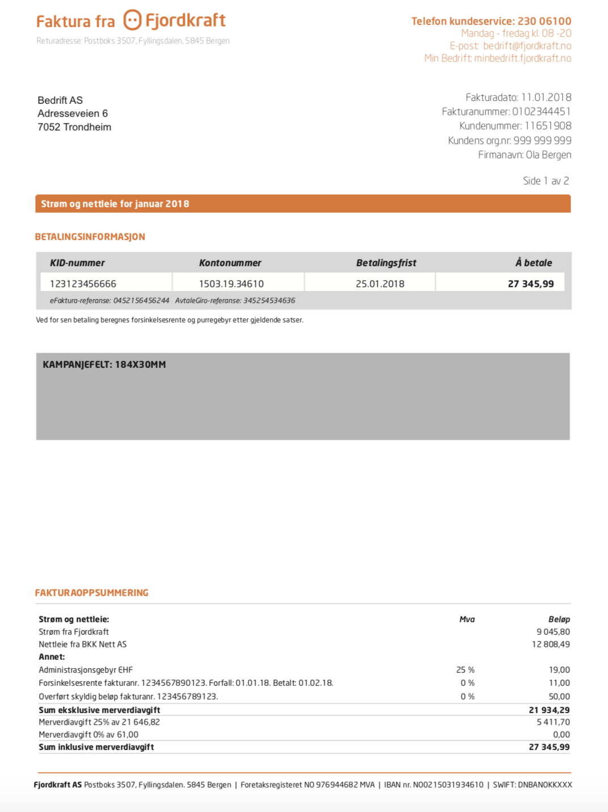

### Mapping table for basic layout, Page 1

Unless other is stated, all tags will be available in Statement.

|  |  |  |
| --- | --- | --- |
| **Layout element** | **Tag** | **Comment** |
| “Bedrift AS” | <CareOfName> |  |
| “Adresseveien 6” | <Address1> | If <Address2> contains data, it must be shown on next line |
| “7052 Trondheim” | <PostCode> <City> | If <Region> is not “NO”, value in <Country> must be sown on next line |
| Fakturadato | <StatementDate> |  |
| Fakturanummer | <AccountNumber> + <SequenceNumber> | Concatenated |
| Kundenummer | <NationalId> |  |
| Kundens org.nummer | <VatId> |  |
| Firmanavn | <Name> |  |
| “Strøm og nettleie for JANUAR 2018” | <StartDate> - <EndDate> | “for JANUAR 2018” should only be visible if all consumption is from the same period (month). Month and year is retrieved from attachment.  If invoice only has strøm, the text should be “Strøm [for JANUAR 2018]  If invoice only has nettleie, the text should be “Nettleie [for JANUAR 2018] |
| KID-nummer | <StatementOcrNumber> |  |
| Kontonummer |  | Configuration per brand |
| Betalingsfrist | <DueDate> |  |
| Å betale | <CurrentClaim> | The text “Å betale” should change to “Tilgode” if <currentclaim> < 0 |
| efaktura-referanse | <AccountNumber> |  |
| avtalegiro-referanse | <StatementOcrNumber> |  |
| “Strøm fra Fjordkraft” | The text “Strøm fra Fjordkraft” is generated from  <Transaction>  …  <TransactionCategory>  KR;Strøm fra Fjordkraft </TransactionCategory> | The sum of <Amount> from all transactions with distribution name Kraft. <Distributions>  <Distribution>  <Name>Kraft</Name>  “mva” column should print 25% if all orderlines on following pages for strøm has vat=25% |
| Nettleie fra “BKK Nett AS” | The text “Nettleie fra BKK Nett AS” is generated from  <Transaction>  …  <TransactionCategory>  NE;Nettleie fra BKK Nett AS </TransactionCategory> | The sum of <Amount> from all transactions with distribution name NETT. <Distributions>  <Distribution>  <Name>NETT</Name>  “mva” column should print 25% if all orderlines on follwing pages for grid has vat=25% |
| Annet: |  | Se description below this table. |
| Sum eksklusive merverdiavgift | Sum of all Beløp above | Calculation |
| Merverdiavgift 25% av **xxxx** | <TotalVatAmount> | Calculation.  **xxxx** is the sum of all lines above from “Annet” where mva=25% + the sum of all xxxx from other pages with mva=25% |
| Merverdiavgift 0% av xxxx | Sum of all transactions with mva=0% | Calculation.  **xxxx** is the sum of all lines above from “Annet” where mva=0% + the sum of all xxxx from other pages with mva=0% |
| Sum inklusive merverdiavgift | <currentclaim> |  |

**Annet:**

This is a list of all lineitems and transactions that is not of type “NETT” or “Kraft”. All these itms should be mappede according to the following table.

|  |  |  |
| --- | --- | --- |
| **Layout element** | **Tag** | **Comment** |
| Text on the left | <LineItemCategory> or <TransactionCategory> | LineItemCategory for all LineItems, and TransactionCategory for all transactions  NB: Leave out the IB; and NA; transactions |
| Mva | This % has to be calculated based on  <Amount>-39.20</Amount>  <VatAmount>-9.80</VatAmount | Only applicable for transaction. Always 0% for LineItems  Formula:  VatAmount / Amount * 100 |

The campaign image should be added to the grey box according to the dimensions stated on the image.

## 2 - Layout with only one meter - page 1

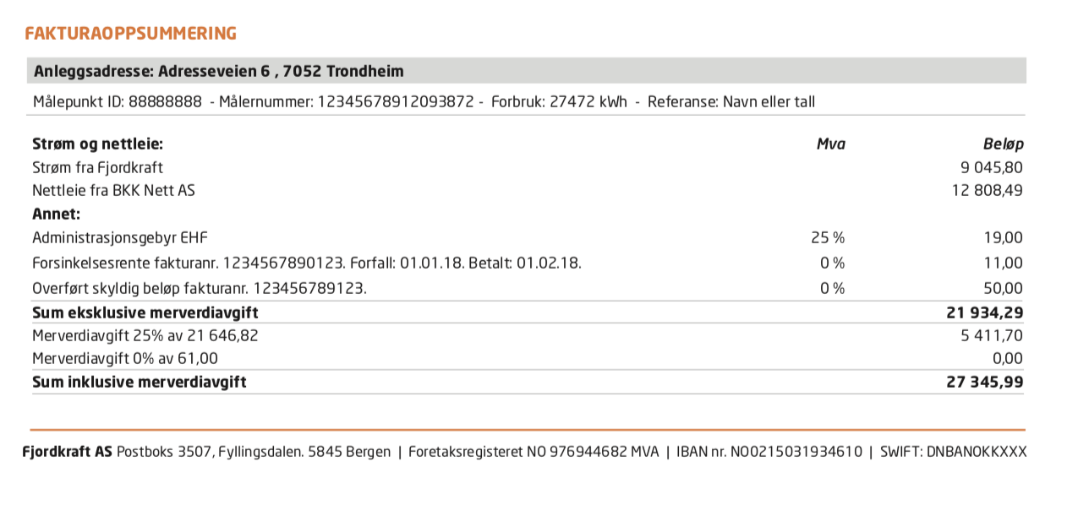

For layouts regarding only one meter, there is a added section in “FAKTURAOPPSUMMERING” with meter details. Mapping described in table below. All other elements on page 1 is identical with standard template. In this table, all elements are retrieved from attachment unless otherwise is specified.

|  |  |  |
| --- | --- | --- |
| **Layout element** | **Tag** | **Comment** |
| Anleggsadresse | <supplypointinfo-117-> streetno | If streetno is not present, use Freetext from transaction |
| MålepunktID | <ObjectId> | Under <SupplyPointInfo-117> |
| Målernummer | <MeterID> | Under <SupplyPointInfo-117> |
| Forbruk | <TotConsCurrCounter> | Under <SupplyPointInfo-117> |
| Referanse | <Description> | Under <SupplyPointInfo-117> |

### Basic template - page 2

This page will be identical for all templates, but there will be one page like this for each meter. Note that this page is a summary of all details for both grid and consumption for each meterID.

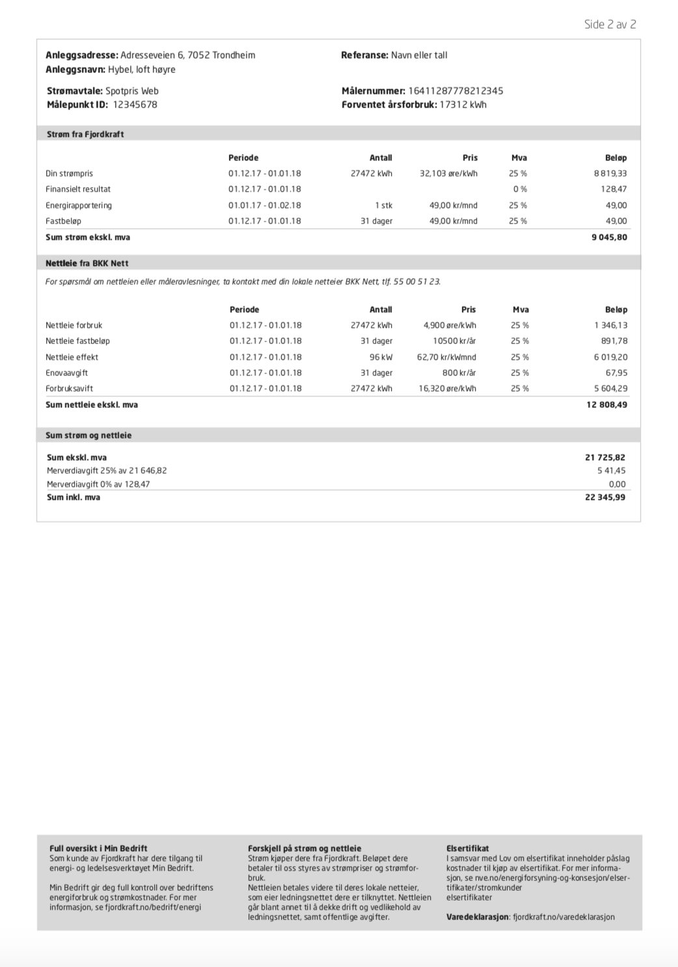

### Mapping table for basic layout, Page 2

### Heading

|  |  |  |
| --- | --- | --- |
| **Layout element** | **Tag** | **Comment** |
| Anleggsadresse |  | StreetNo |
| Anleggsnavn | <Description> | Under <SupplyPointInfo-117> |
| Strømavtale | <Description> | From attachment within ProductParameters-118 |
| MålepunktID | <ObjectID> |  |
| Referanse | <FAKTURA_MERKE_SO> |  |
| Målernummer | <MeterID> |  |
| Forventet årsforbruk | <AnnualConsumption> |  |

### Strøm-table

|  |  |  |
| --- | --- | --- |
| **Layout element** | **Tag** | **Comment** |
| Strøm fra Fjordkraft |  | “Strøm fra xxx“ where xxx is configured brandname |
| “Text of orderline” | <Text> | <InvoiceLine-120> |
| Periode | StartDate - EndDate | <InvoiceLine-120> |
| Antall | <Basis> | Same logic as for template for individuals |
| Pris | <PriceRate> | <InvoiceLine-120> |
| Mva | <VatRate> | <InvoiceLine-120> |
| Beløp | <Net> | <InvoiceLine-120> |
| Sum strøm ekskl. mva | <NetTotal> | <InvoiceOrderAmounts-113> |

Grid-table EHF-format

|  |  |  |
| --- | --- | --- |
| **Layout element** | **Tag** | **Comment** |
| Nettleie fra BKK Nett |  | “Nettleie fra xxx” where xxx is ... |
| ...ta kontakt med din lokale netteier xxx, tlf. yyy |  | xxx is the same as above, while yyy is configuration for each gridowner |
| “Text of orderline” | <cbc:Name> |  |
| Periode | cac:invoiceperiod, cbc:startdate, cbc:enddate |  |
| Antall | <cbc:InvoicedQuantity unitCode="KWH" unitCodeListID="UNECERec20">17500.000</cbc:InvoicedQuantity> | unitCode contains denomination  If unitCode="DAY", then “dager” should be printed  If <cbc:InvoicedQuantity unitCode="NAR" then “kWh” should be printed and price should be handled as “øre/kWh” |
| Pris | <cac:Price><cbc:PriceAmount currencyID="NOK">16.6000</cbc:PriceAmount><cbc:BaseQuantity>100</cbc:BaseQuantity></cac:Price> | BaseQuantity=100 means that the price is 0,166 in this example  Only 3 decimals |
| Mva | <cbc:Percent> |  |
| Beløp | <cbc:LineExtensionAmount currencyID="NOK">2800.00</cbc:LineExtensionAmount> |  |
| Sum nettleie ekskl. mva | <cbc:TaxExclusiveAmount |  |

Grid-table E2B-format

|  |  |  |
| --- | --- | --- |
| **Layout element** | **Tag** | **Comment** |
| Nettleie fra BKK Nett |  | “Nettleie fra xxx” where xxx is ... |
| “Text of orderline” | <Description> |  |
| Periode | <StartDate> - <EndDate> |  |
| Antall | <QuantityInvoiced> | Denomination: <UnitOfMeasure> |
| Pris | <Ref> <Code>UnitPriceGross</Code>  <Text>0.17500</Text>  </Ref> | Denomination: <PriceDenomination> |
| Mva | <VatInfo>  <VatPercent> |  |
| Beløp | <LineItemAmount> |  |
| Sum nettleie ekskl. mva | <InvoiceTotals> <LineItemTotalsAmount> |  |

“Sum strøm og nettleie”-tablex`

|  |  |  |
| --- | --- | --- |
| **Layout element** | **Tag** | **Comment** |
| Sum strøm og nettleie |  | The sum of strøm and nettleie on this page |
| Merverdiavgift 25% av xxxx | <vat> (from emuxml) + <cbc:TaxAmount currencyID="NOK"> for EHF or  <VatTotalsAmount> for E2B | xxxx is the sum of all amounts with vat=25%  This amount is used in calculation on page 1 |
| Merverdiavgift 0% av xxxx | 0,00 | xxxx is the sum of all amounts with vat=0%  This amount is used in calculation on page 1 |
| Sum inkl mva | The sum of the three amounts above. |  |

## 3 - Invoices with positive amount to be paid

These invoices can be identified by negative value in <currentclaim>.

No changes on page 2.

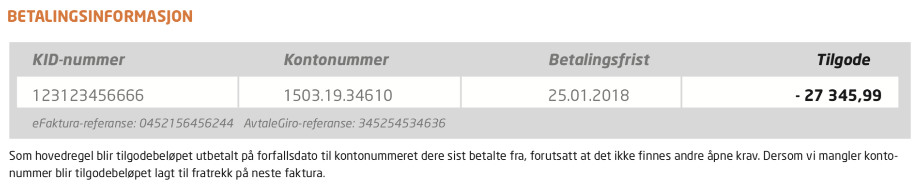

The following is changed from the standard verson:

* All text but the last column is made grey
* The text “Å betale” is changed to “Tilgode”
* New text under the table

## 4 - Final Invoice version

No changes on page 1.

Meters with final invoice can be identified by value invoicetype=O from attachment.

In this case the text “ - OPPHØR” should be appended in header.

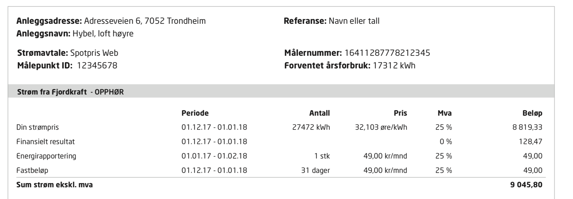

## 5 - Direct Debit enabled version

TBD

## 6 - Metersummary

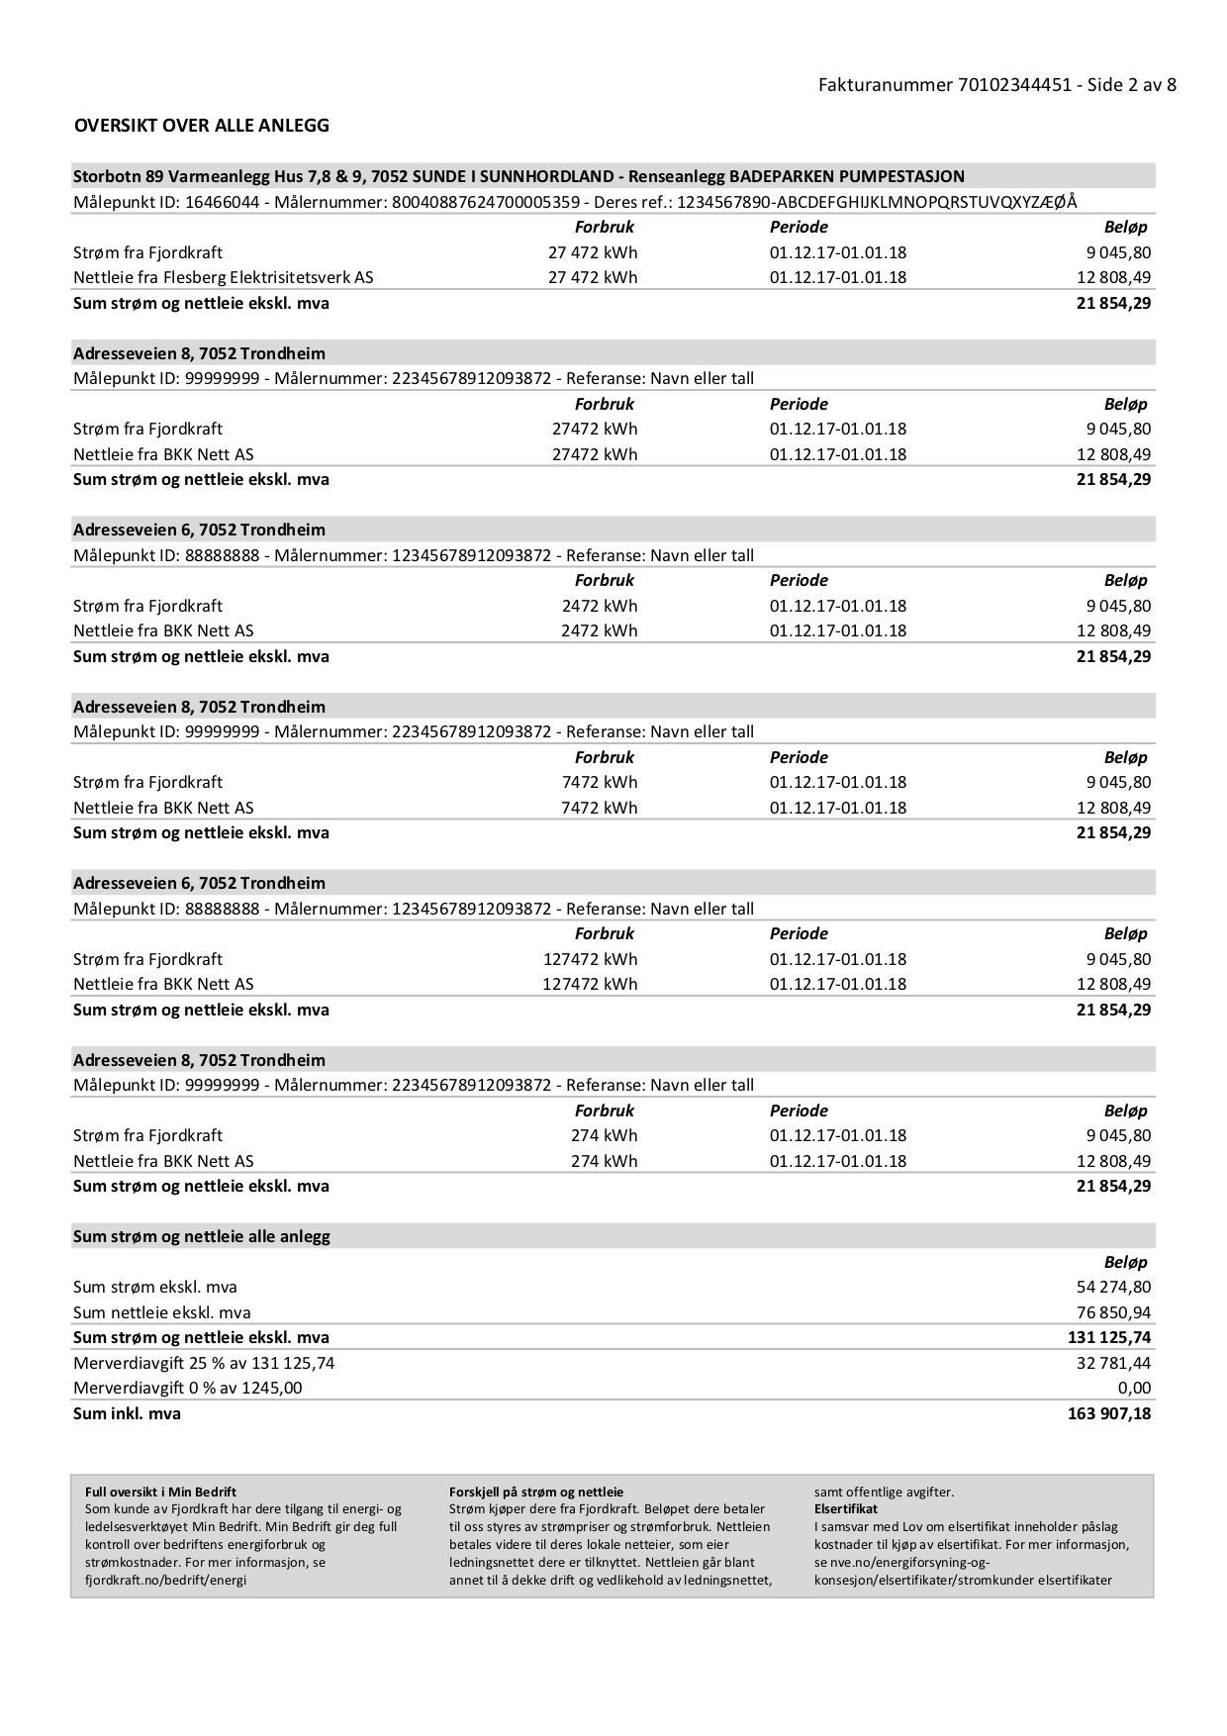

Mapping

|  |  |
| --- | --- |
| **Value** | **Mapping** |
| “Fakturanummer xxxxxxxxxxxxxx” | “Fakturanummer “ <accountnumber><sequencenumber> |
| Header for each meter | <supplypointinfo-117-> streetno from emuxml, freetext from transaction if streetno is missing |
| MålepunktID | <ObjectID> |
| Målernummer | <MeterID> |
| Referanse | <FAKTURA_MERKE_SO> |
| “Strøm fra xxx” | “Strøm fra “ <brand> where brand is the configured value for this organization. |
| “Nettleie fra xxx” | “Nettleie fra “ <ldc1> (from emuxml). I guess you use this tag from earler where you print the grid owners name? |
| Forbruk strøm | The sum of all <MethodFinalC-Reading> records from emuxml for this meter |
| Forbruk grid | Blank |
| Periode (strøm) | StartDate - EndDate from invoiceline-120. First startdate and last enddate for meter. |
| Periode (grid) | EHF:  cac:invoiceperiod, cbc:startdate, cbc:enddate  e2b:  <StartDate> - <EndDate>  First startdate and last enddate for meter. |
| Beløp (Strøm) | Sum of all <NetTotal> for this meter |
| Beløp (Grid) | e2B  Sum of all <InvoiceTotals> <LineItemTotalsAmount> for this meter  EHF:  Sum of all <cbc:TaxExclusiveAmount for this meter |
| Sum strøm eks mva | The sum of all “Beløp strøm” |
| Sum nettleie ekskl mva | The sum of all “Beløp grid” |
| Sum strøm og nettleie ekskl mva | The sum of the the 2 above |
| “Merverdiavgift 25% av xxx” | xxx is the sum of all amounts with vat=25%  Beløp=  <vat> (from emuxml) + <cbc:TaxAmount currencyID="NOK"> for EHF or  <VatTotalsAmount> for E2B |
| “Merverdiavgift 0% av xxx” | xxx is the sum of all amounts with vat=0%  Beløp=0.00 |